Data Communication & Computer Networks
KAT2 , GROUP WORK FOR FINAL TEST IN SOCKET PROGRAMMING.



xxxxxx 0000000yyyy
ppppppp, 0000000qqqq
etc.

Table of Contents

1. How to Send Message to a Certain Client? 4
a. First, we need to add a new text panel , and let users type the receiver of the message 4
b. After we make sure that the GUI is working, now we need to make the modification to the code, the concept is simple, until know, we sent a message by transporting a message to output buffer, and receive it via the socket’s input buffer. 4
c. Now, if we want to send to specific client, we need to add new token on the content, to specify the username of the client we want to sent the message to. 4
d. Now that we have sent the target client, we now need to make a modifications to the code. 5
i. (Dirty Way) , on the client side, we just need to change the JTextField .setText( ) arguments, so that it will not print a message IF(target != username ) this means, if the target of the message is not the same as that client’s username, it will not print the text 5
ii. (Real way ) , on the server side, before we send a message to client, the thread iterates through a vector consisting all of the client socket object, so that it will sent the messages to all client sockets that already connected. We need to make a little modification to the loop, 5
e. Result : 5
2. When certain client disconnect then in Server that specific client name will appear –not just “Lost a connection” how to make this happen ? 6
a. This one is a little bit easier, but also trickier, to do this, we will make use of the exception handling In JAVA 6
b. So , when an EXCEPTION in socket thread ( the one that always listens to the client message in server ), the server sent the command above to all of the clients that is still connected , and each client will print out the username, indicating which users is now disconnected from the server. 6
3. How to make bottom label (“Techworld3g”) changed to Client’s name 7
a. This one is pretty simple, instead of setting the JLabel to equal “TechWorld3g” on the form editor, we need to code that itself and set it to username. We can do this simply by caling 7
b. Result : 8
4. How to send file only to a certain client ? 8
a. This one is probably the hardest for our group , since we need to add new functionality as well as trying to maintain the codebase with exception handling and custom command for sending a file to a certain client.. 8
b. First, we need to create a new GUI to do all the work, on this case, our group created a new JMenu , and JMenuItem 8
c. After the GUI is up and running, we need to add a new code in the server side, which is another command , on this case, we name this command “CMD_SENDFILE” 8
d. The last step ( but not least, is to add a Exception handling to handle all the response that server and client should have if they failed to send a file, we will create another command with this format : 12
e. Voila, we are done now. 13

Table of Figures

Fig. 1. Interfaces: Clients in the foreground and Server (background black – you should change this to no colour) 5
Fig. 2. Interface: three clients shown 7

- How to Send Message to a Certain Client?
To do this, we have to make a modification to the GUI, and to the code.
  - First, we need to add a new text panel , and let users type the receiver of the message
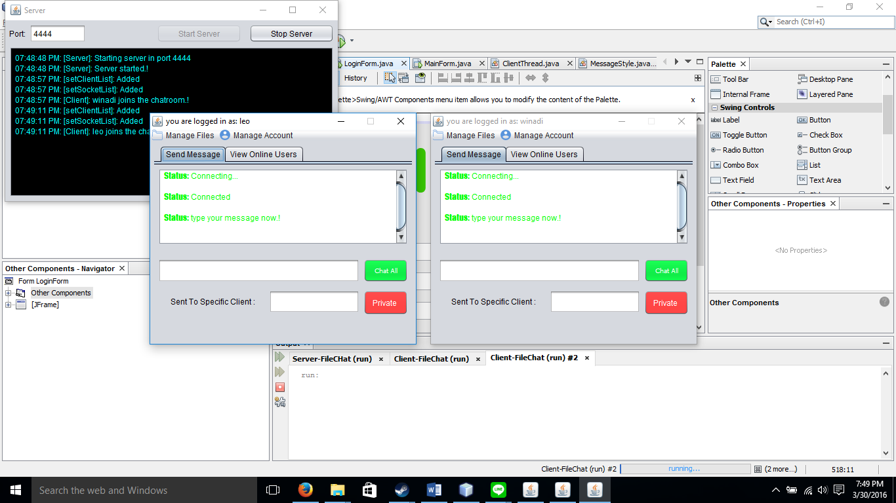
Fig. 1. Interfaces: Clients in the foreground and Server (background black – you should change this to no colour)

In Fig. 1, we added a new Textfield , label ( send to Specific client ) and a private message button to send a message to specific client.
  - After we make sure that the GUI is working, now we need to make the modification to the code, the concept is simple, until know, we sent a message by transporting a message to output buffer, and receive it via the socket’s input buffer, [1] using Java script.

This message is sent as a long string consisting multiple tokens , on our case, before the modification, the content of the message buffer is :

CMD_XXX + Content
CMD Represents command, which will be sent different tokens for different kind of message that we send, for example , CMD_CHATALL for message with global receiver and content token is different for every message. To send a message to client, we set the content token to be = username ( sender) + “ “ (delimiter) + message.

  - Now, if we want to send to specific client, we need to add new token on the content, to specify the username of the client we want to send the message to.
So , in the code, we changed the token that will be sent to be
username ( sender) + “ “ (delimiter) +target+ “ “ (delimiter) + message.

  - Now that we have sent the target client, we now need to make a modification to the code.
There’s 2 way of doing this ,
    - (Dirty Way) , on the client side, we just need to change the JTextField .setText( ) arguments [2], so that it will not print a message IF(target != username ) this means, if the target of the message is not the same as that client’s username, it will not print the text
    - (Real way ) , on the server side, before we send a message to client, the thread iterates through a vector consisting all of the client socket object, so that it will send the messages to all client sockets that already connected. We need to make a little modification to the loop,
Before : bla-bla-bla :-)
This way ,we add one more if , so that if the element in the server socket list is not equal to target ,it will not send the message.
This method is way better because we avoid sending unnecessary tokens to the client , and this method is way more secure because the client that is not the target does not receive any kind of output buffer that is not sent to him/her.
  - Result :
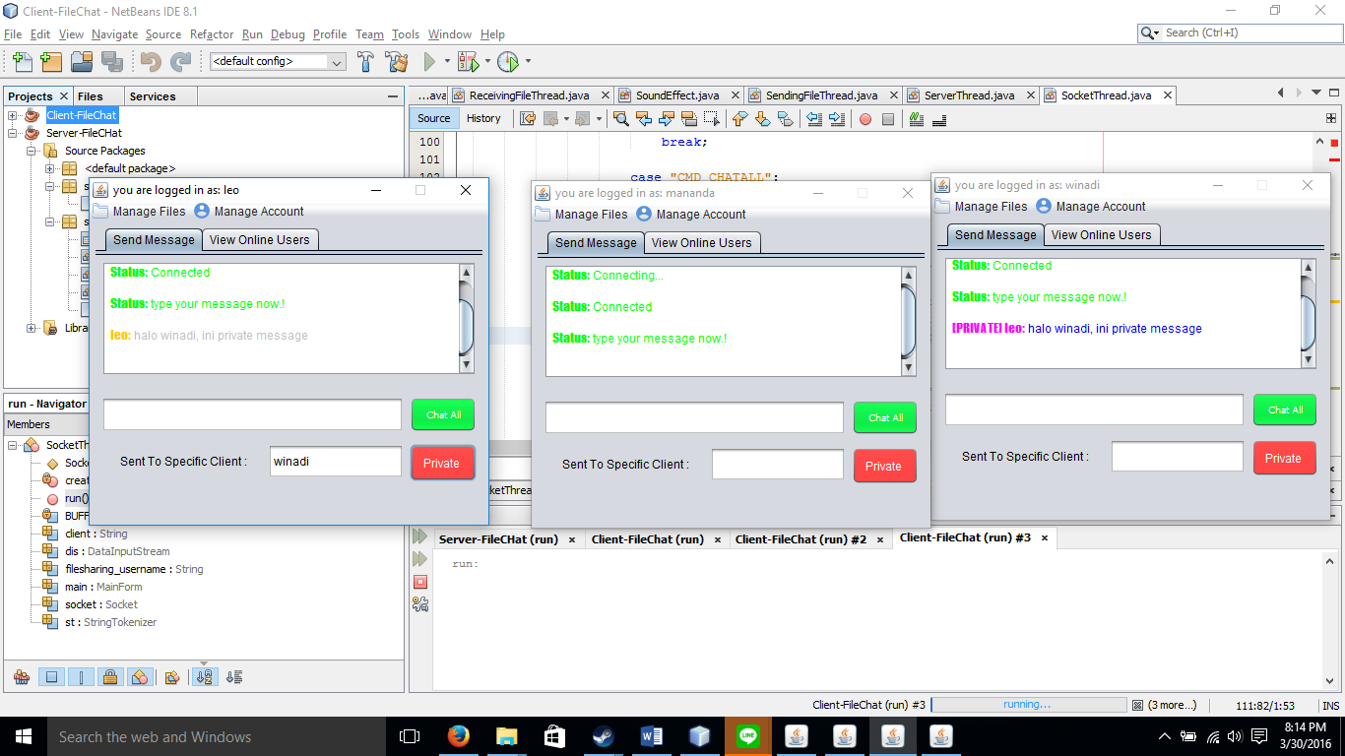
Fig. 2. Interface: three clients shown

Now, in Fig. 2, we can see that the message isn’t received by mananda, which is not the target of leo’s private chat.
- When certain client disconnects then in Server that specific client name will appear –not just “Lost a connection” how to make this happen ?

  - This one is a little bit easier, but also trickier, to do this, we will make use of the exception handling In JAVA

When a client disconnects, we will send a message ( means we create another entry for CMD) ,
So when a user decided to disconnect, we will send a message with this token to all clients
CMD_DC + “ “ (delimiter) + username ( sender)
  - So , when an EXCEPTION in socket thread ( the one that always listens to the client message in server ), the server sent the command above to all of the clients that is still connected , and each client will print out the username, indicating which users is now disconnected from the server.
Result : (deleted)

After mananda disconnect :
Bla-bla-bla

- How to make bottom label (“Techworld3g”) changed to Client’s name
  - This one is pretty simple, instead of setting the JLabel to equal “TechWorld3g” on the form editor, we need to code that itself and set it to username. We can do this simply by calling

Bla-bla-bla

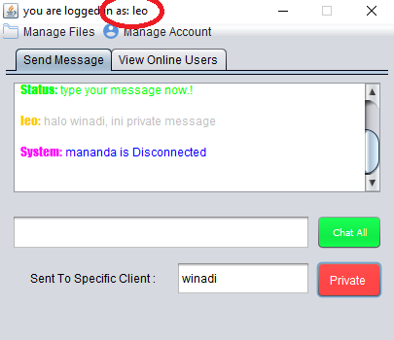
  - Result :

In this case, I make it as a title instead of a label on the bottom because it looks much cooler and makes much more sense, but It’s the same JLabel, just different position.

- How to send file only to a certain client ?

  - This one is probably the hardest for our group , since we need to add new functionality as well as trying to maintain the codebase with exception handling and custom command for sending a file to a certain client..
  - First, we need to create a new GUI to do all the work, on this case, our group created a new JMenu , and JMenuItem
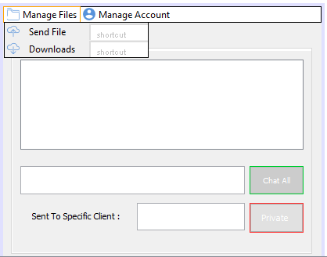
After the GUI is up and running, we need to add a new code in the server side, which is another command , on this case, we name this command Bla-bla-bla ….
  - So when a user invokes the send file menu item, it will choose an item and prompts the user to enter a receiver username
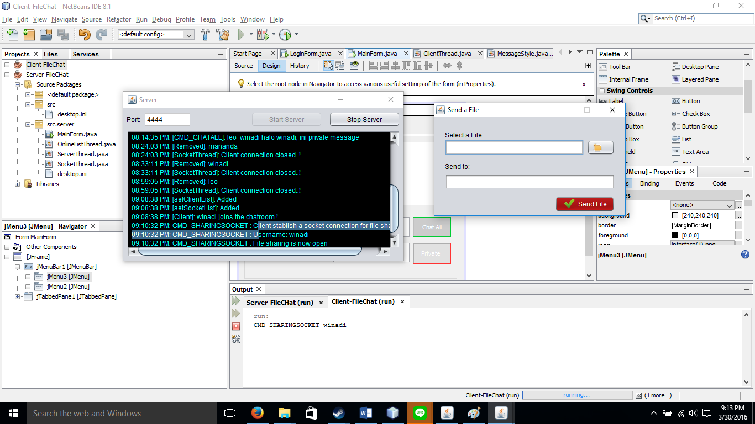

as you can see, to even make this start, we need to a command to our server’s code, which is ……….. Bla-bla-bla
this means, we want to open another socket just for file transfer, because apparently we cannot use the same socket to transfer different buffer at the same time ( file and message )
Bla-bla-bla

Bla-bla-bla

the above code is used to indicate whether client successfully open a new socket or not, if It succeeded, we will use this to tell server that client socket is now opened to share a file, and on the other end, the receiver’s socket will also need to be opened , so the server opens a new client socket ( for the receiver, because of course we don’t want the receiver who does not know anything to open a socket for themselves to receive files )
then we create a new command for Bla-bla-bla, which is where all the magic would happen, after we get sender’s sharing socket and open a receiver socket, the CMD_SENDFILE has this format
Bla-bla-bla
And then, we open socket input and output buffer by the data that we get from this token.
And, this code will write the file to the socket output stream ( receiver socket listener )
Bla-bla-bla
The way we send the file, is writing every bytes of the file one by one into the output buffer.
Now we need another command to indicate whether the file transfer is finished we add a CMD_FILE_RESPONSE command on the server side,
Bla-bla-bla
This command will be used to indicate the response of both sender and the receiver of the file, this can either give a dialogue box to the sender that indicates the transfer is completed ( or failed) or a dialogue box to the receiver that indicates they successfully received a file from the sender.
So, the code is simple
Bla-bla-bla
Result ( until now ) :
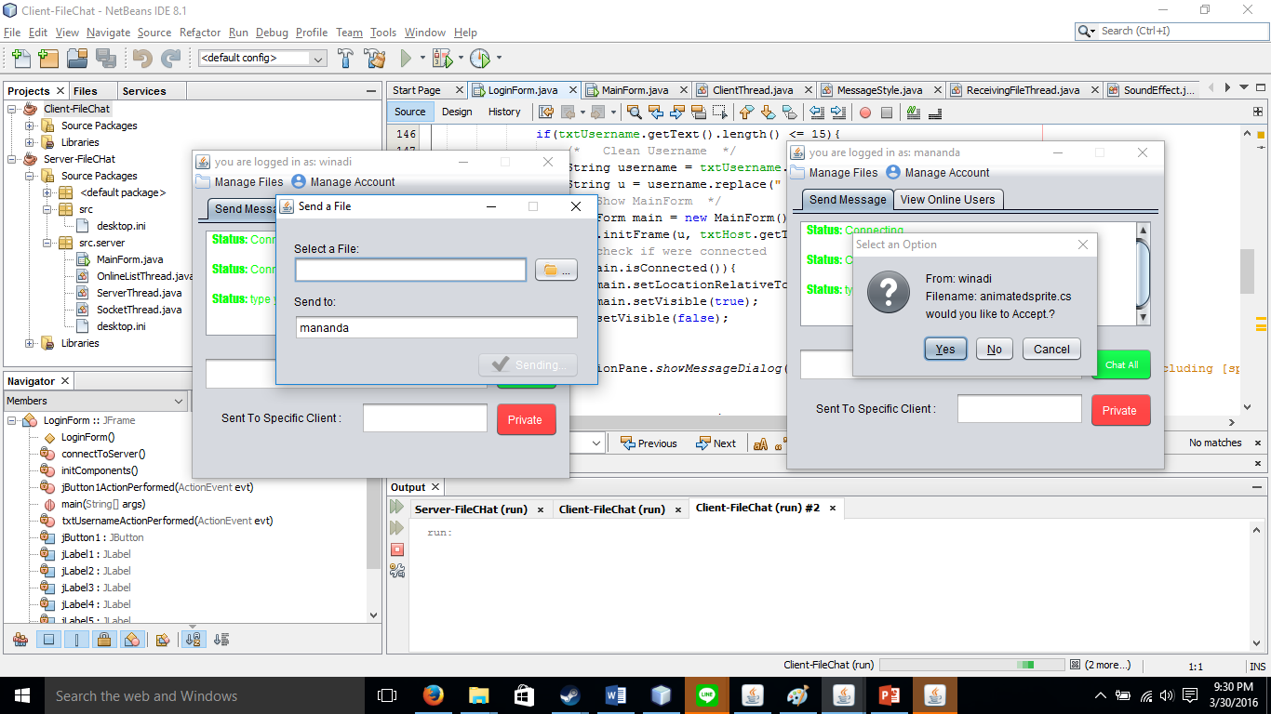

File sent response :
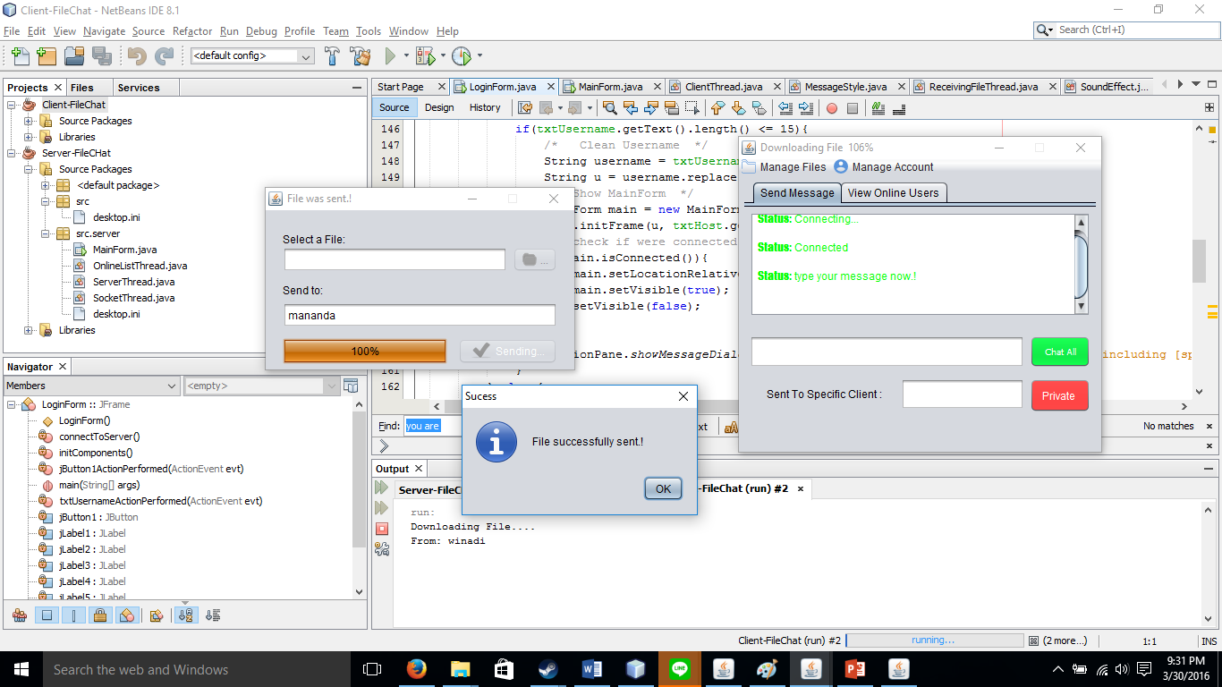
File Received Response :
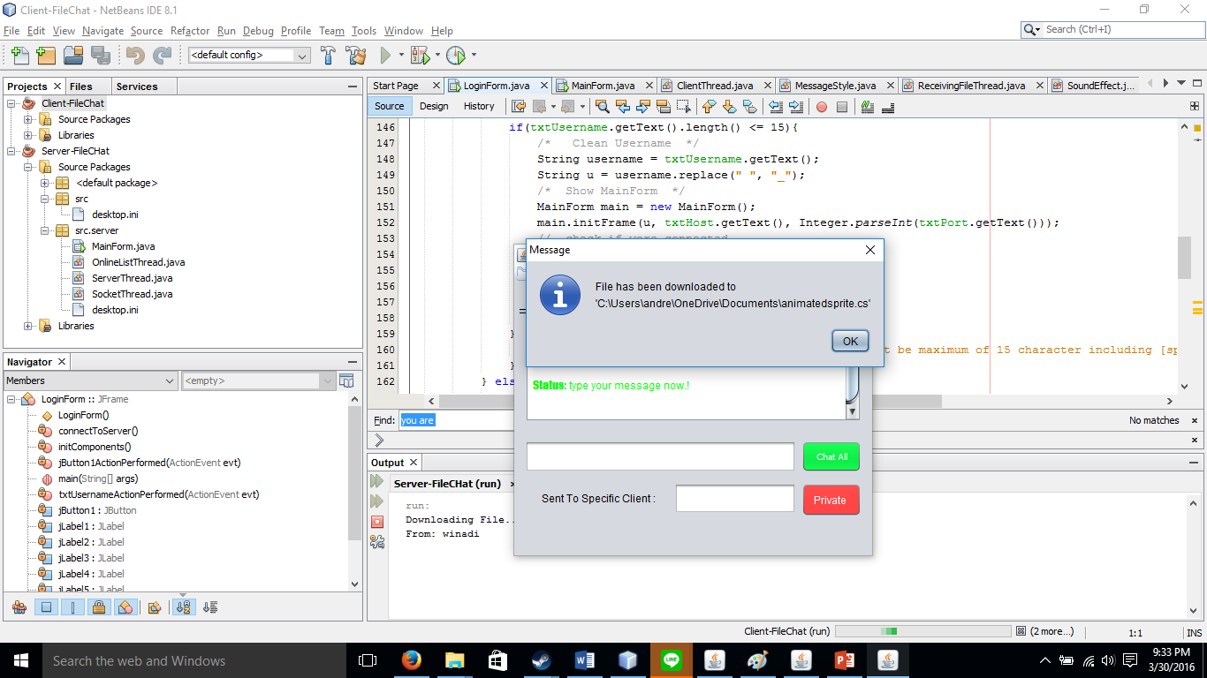
  - The last step ( but not least, is to add an Exception handling to handle all the response that server and client should have if they failed to send a file, we will create another command with this format :
- Bla-bla-bla
So that when we failed to send a file, it will give this result :
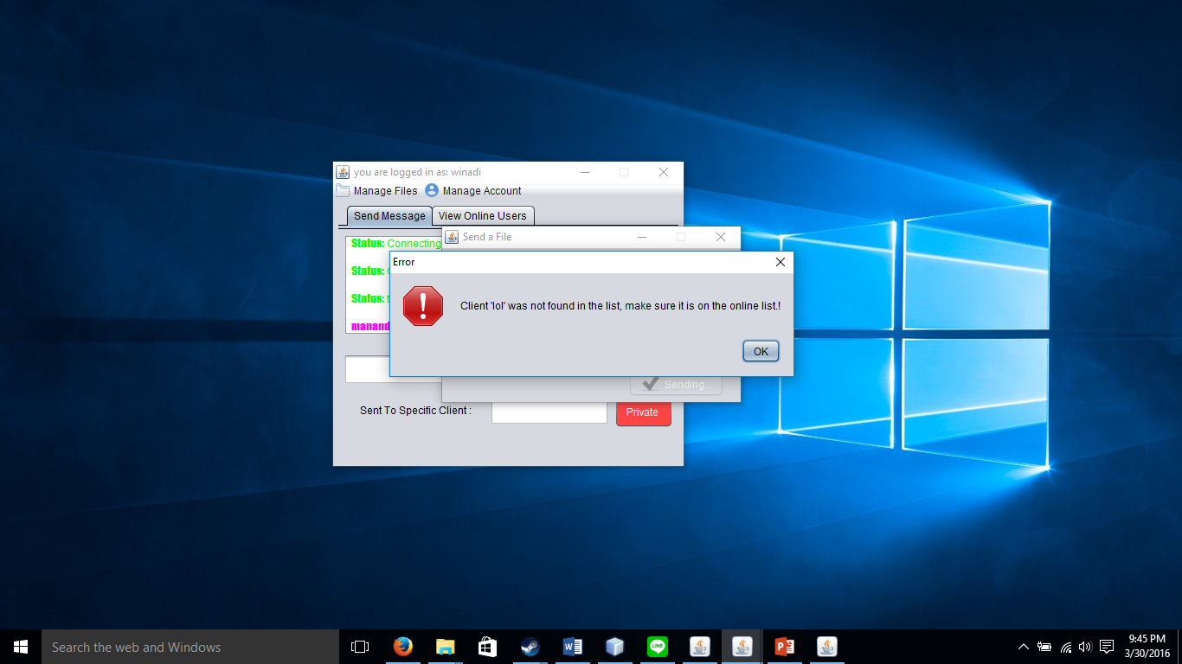
The code is like this :
Bla-bla-bla
the client thread will response using this :
Bla-bla-bla
or this :
Bla-bla-bla

  - Voila, we are done now.

References

[1] “What is Java? - Definition from WhatIs.com - SearchSOA - TechTarget.”
[2] “The Java Tutorials.” [Online]. Available: https://docs.oracle.com/javase/tutorial/uiswing/components/textfield.html.

